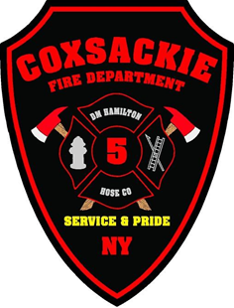
COXSACKIE FIRE DEPARTMENT
119 MANSION STREET
COXSACKIE, NEW YORK 12051
(518)731-2718 Ext. 305
Firechief@villageofcoxsackie.com
Fire Council
October 24, 2023
Roll Call- Earl Martin IV, Shawn Burdick, Dominic Yannazzone, TJ Moore, Victor Cespedes, Courtney Stickle , James Sandberg.
Meeting called to order by Chief Burdick at 19:30Hrs
Pledge to the Flag
Minutes from previous meeting read motion to approve by Dominic 2nd by Victor motion carried.
Treasurer report read motion by Dominic to accept as read 2nd by TJ motion carried.
Mail- Fire News Papers,
Membership- Hose 3 Christine Martin letter to go from active to Social status.
Chief Report
Chief Yannazzone – Everyone is doing a good job, Went over members that need their physicals.
Chief Burdick- Department drill November 8th, 18:00 at Bethany Village, asked if DM Ladies naked goods for the Parade of lights, and Hose 3 Ladies to do the Hot Chocolate.
Warden Report-
Committee- Golf Earl will reach out to secure the Course for next year.
Old Business – Nothing
New Business – DM would like to know if 5-1 can go to Fireman’s home 10/28 , Approved by Chief Burdick.
Motion for adjournment by Shawn 2nd by Dom motion carried. 19:42Hrs.

